Beach Week  Week 1 | Monday, June 19  Summer Camp Begins  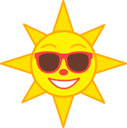 |  | Tuesday, June 20  Sand Dollar Craft | Wednesday, June 21  Water Play  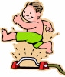 | Thursday, June 22  Jellyfish Craft  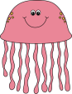 | Friday, June 23  Beach Party  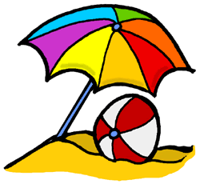
Bug Week  Week 2 | Monday, June 26  Popsicle Day |  | Tuesday, June 27  Butterfly Craft | Wednesday, June 28  Water Play | Thursday, June 29  Bug Catchers  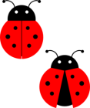 | Friday, June 30  “Bug”noculars  Bug Hunt
Party in the USA  Week 3 | Monday, July 3  Fourth of July Party |  | Tuesday, July 4  FOURTH OF JULY  HOLIDAY  CAMP CLOSED | Wednesday, July 5  Water Play | Thursday, July 6  Fireworks! | Friday, July 7  Fourth of July Craft
Everyday  Heroes  Week 4 | Monday, July 10  Policeman Day |  | Tuesday, July 11  Fireman Day | Wednesday, July 12  Water Play | Thursday, July 13  Ambulance Craft | Friday, July 14  Ice Cream Party
Book Week  Week 5 | Monday, July 17  Flat “Camper” Day |  | Tuesday, July 18  Splat the Cat  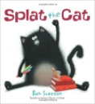 | Wednesday, July 19  Water Play | Thursday, July 20  Dr. Seuss Day  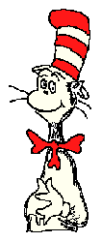 | Friday, July 21  Pete the Cat  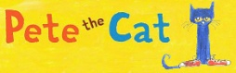
Pirate Week  Week 6 | Monday, July 24  Pirate Hats |  | Tuesday, July 25  Pirate Telescope | Wednesday, July 26  Water Play | Thursday, July 27  Treasure Chests  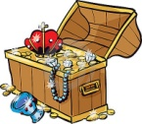 | Friday, July 28  Treasure Hunt  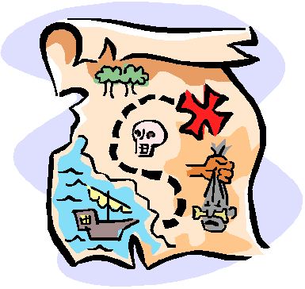
Winter in August  Week 7 |  | Monday, July 31  Snowflake Craft | Tuesday, August 1  Snowman Craft  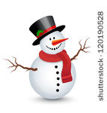 | Wednesday, August 2  Water Play | Thursday, August 3  Snowball Games  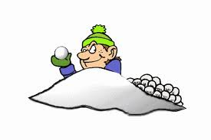 | Friday, August 4  Popsicle Day
Out of Space  Week 8 |  | Monday, August 7  Rocket Craft | Tuesday, August 8  Earth Craft | Wednesday, August 9  Water Play | Thursday, August 10  Oh My Stars | Friday, August 11  End of Camp Celebration

